Requirements/Design Specification

**April2015 Emergency Fixes**

Revision History

|  |  |  |  |
| --- | --- | --- | --- |
| **Date** | **Revision** | **Description** | **Author** |
| 4/28/2015 | 1.0 | Initial Version with Requirements | Roger Behm |
|  |  |  |  |
|  |  |  |  |
|  |  |  |  |
|  |  |  |  |

The information furnished herein by Republic Services Inc. is proprietary and confidential to Republic Services Inc. personnel and is not to be duplicated, published, or disclosed to any third party in whole or in part without permission from Republic Services, Inc.

© Copyright 2012, Republic Services Inc. - All rights reserved.

Table of contents

1 Business Requirements 6

1.1 Purpose of the Design Specification 6

1.1.1 Bug list for current release 6

2 Assumptions 6

3 Design 6

3.1 #563 Error Message After Adding Ad Hoc Item 6

3.2 #549 Existing Customer Close Container Group CSA Errors 7

3.3 #544 Existing Customer Waive Admin Fees Not Showing Waived on Customer CSA 7

3.4 #540 Wrong Trans/Reason Codes and No Competitor Code on CSA 7

3.5 #539 XML Error Due to Use of “&” in Devlivery and Service Notes 7

3.6 #532 CSA Trans/Reason Code for Existing Customers New Site is wrong. 8

3.7 #509 Commision Info Able To Be Seen In Prod 8

Issue 8

4 InfoPro Interface 9

5 Report Changes 9

6 Appendix 9

# Business Requirements

## Purpose of the Design Specification

This document highlights items to be fixed and implemented for the titled release.

### Bug list for current release

| GitHub Item  Number | **Description** |
| --- | --- |
| 563 | Error message after adding Ad Hoc item |
| 549 | Existing Customer close container group CSA errors |
| 547 | [Compensation Table Is Not Correct](https://github.com/RepublicServicesRepository/Capture/issues/547) (PDC) |
| 544 | Existing customer waive admin fees not showing waived on Customer CSA |
| 540 | [Wrong Trans/Reason codes and no competitor code on CSA for New/New for older quotes](https://github.com/RepublicServicesRepository/Capture/issues/540) |
| 539 | [XML error due to use of & in delivery and service notes](https://github.com/RepublicServicesRepository/Capture/issues/539) |
| 532 | [CSA trans/reason code for existing customer new site wrong](https://github.com/RepublicServicesRepository/Capture/issues/532) |
| 515 | [Compensation Data Changes](https://github.com/RepublicServicesRepository/Capture/issues/515) (PDC) |
| 509 | [Commission info able to be seen in PROD](https://github.com/RepublicServicesRepository/Capture/issues/509) |
|  |  |

# Assumptions

NA

# Design

## #563 Error Message After Adding Ad Hoc Item

**Issue**

Quotes that have Ad Hoc items get an error message after clicking Calc Price Button. Get error message RunTimeException has occurred.

**Design**

Applied setDeliverNotes commerce function change that [**@AaronQuintanilla**](https://github.com/AaronQuintanilla) made to Dev and Test to Dev2. Deployed commerce, so it's ready for retest.

**BI or InfoPro**

No Impact

## #549 Existing Customer Close Container Group CSA Errors

**Issue**

The CSA shows a line item for closing a container group of N and $0 with code of only 06/

**Design**

Fixed this as a part of the setTransactionCode updates for [#540](https://github.com/RepublicServicesRepository/Capture/issues/540), so it can go as a part of the emergency release.

**BI or InfoPro**

No Impact

## #544 Existing Customer Waive Admin Fees Not Showing Waived on Customer CSA

**Issue**

Existing customer that charges all fees. Do a rollback and waive fees. Look at Customer facing CSA. Exempt from does not list Admin fees. In addition, if Admin Fee is applied the CSA is showing it's showing exempt

**Design**

When applying the "Exempt From" fee on the CSA in Doc Engine, the condition was only looking at the read only value. By adding in an XSL snippet, we can change that condition to only add the 'Exempt from Admin Fee' comment if the fee is waived.

The new XSL condition in place is:   
<xsl:if test="$main_doc/admin_readOnly_quote = 'Yes' and not(contains($main_doc/feesToCharge_quote, 'Admin'))" > Administrative Fee </xsl:if>

**BI or InfoPro**

No Impact

## #540 Wrong Trans/Reason Codes and No Competitor Code on CSA

**Issue**

For quotes created prior to the new release, the transaction reason code is 01/02 for new/new and there is no competitor code

**Design**

Need to update the mapping in setTransactionCode whithin commerce.

**BI or InfoPro**

No Impact

## #539 XML Error Due to Use of “&” in Devlivery and Service Notes

**Issue**

If an ampersand is used in the delivery or service notes get an error message.

**Design**

Used a replace function to replace "&" with "and".

**BI or InfoPro**

No Impact

## #532 CSA Trans/Reason Code for Existing Customers New Site is wrong.

**Issue**

Transacition/Reason code shows 01/02 for new site added to existing customer instead of 01/01.

**Design**

This is due to a logic issue in setTransactionCode commerce function. Note, this is only incorrect for an existing customer **with a new site.**

**BI or InfoPro**

No Impact

## #509 Commision Info Able To Be Seen In Prod

## Issue

Rep is able to see Commission info in PROD

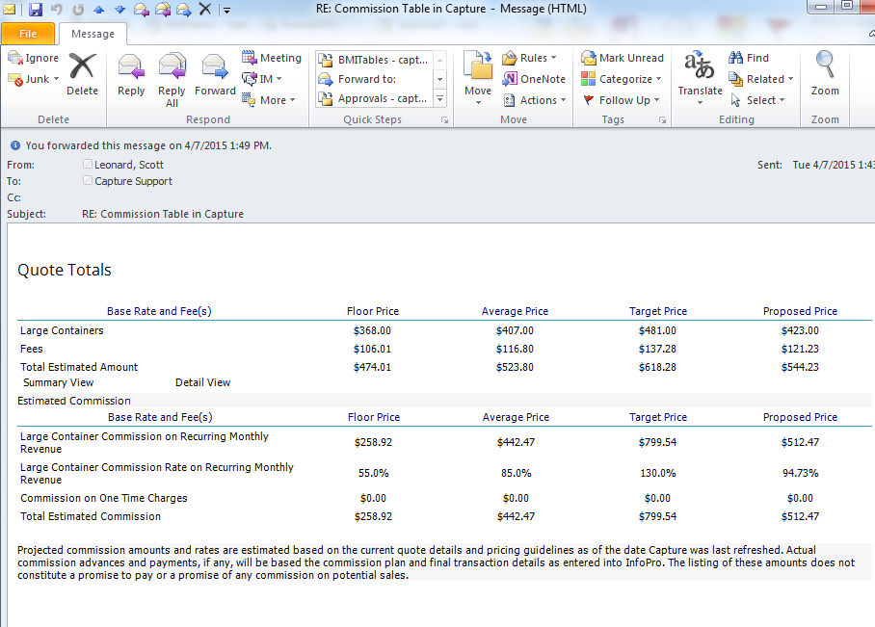

**Design**

It looks like this can be caused via an issue with the logic in calcCommission. When we set the queryResponseOne and queryResponseTwo variables to true, we open ourselves up for displaying comp if there's a problem with the BMQL queries. The logic should be reversed to default to not display comp.

**BI or InfoPro**

No Impact

# InfoPro Interface

No new variable should be needed and no existing variables should be repurposed for any of the above changes.

# Report Changes

NA

# Appendix